**DAILY ONLINE ACTIVITIES SUMMARY**

|  |  |  |  |  |  |  |  |  |
| --- | --- | --- | --- | --- | --- | --- | --- | --- |
| **Date:** | **30/05/2020** | | | | | **Name:** | **Prashant Rama Bhat Kodlekere** | |
| **Sem & Sec** | **4th sem (B sec)** | | | | | **USN:** | **4AL18CS060** | |
| **Online Test Summary** | | | | | | | | |
| **Subject** | | **DATA COMMUNICATION** | | | | | | |
| **Max. Marks** | | **30** | | **Score** | | | **27** | |
| **Certification Course Summary** | | | | | | | | |
| **Course** | **Python3 for biginners in 2020** | | | | | | | |
| **Certificate Provider** | | | **Udemy** | | **Duration** | | | Section 7 and 8 |
| **Coding Challenges** | | | | | | | | |
| **Problem Statement:** Write a java Program to count Uppercase, Lowercase, special character and numeric values for a given String  Top of Form  Bottom of Form | | | | | | | | |
| **Status:Completed** | | | | | | | | |
| **Uploaded the report in Github** | | | | | **YES** | | | |
| **If yes Repository name** | | | | | **https://github.com/prashantkodlekere/codingactivity** | | | |
| **Uploaded the report in slack** | | | | | **YES** | | | |

Online Test Details:

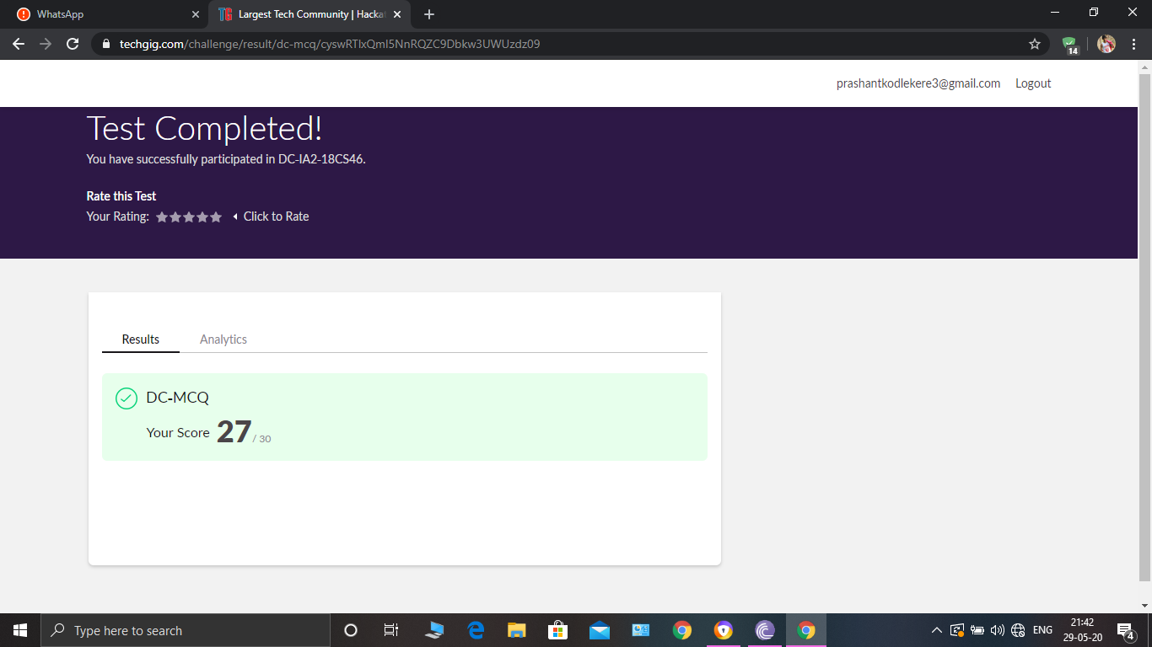

DATA COMMUNICATIONS Internals was conducted. A total of 30 questions were Multiple Choice Questions.

The above snapshot is the result sheet which was mailed to us by the Techgig team.

Certification Course Details:

Course name:Python3 for biginners in 2020(7th and 8th section) 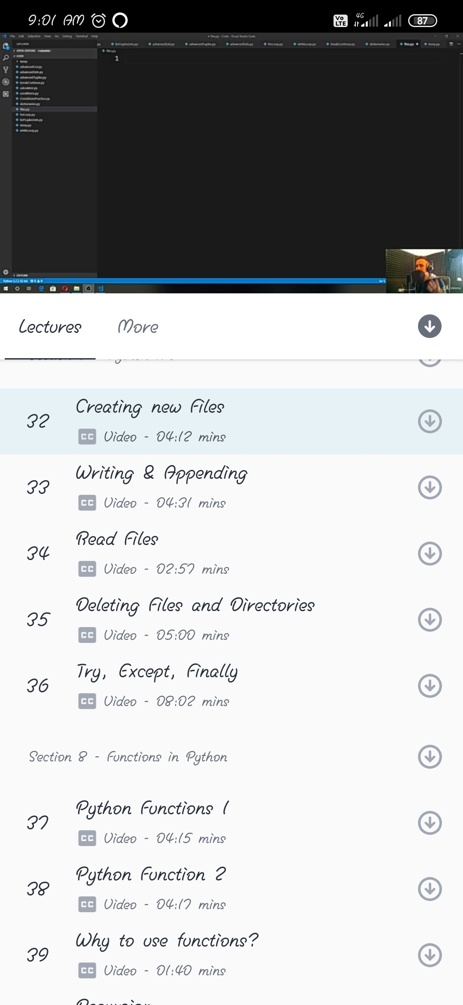

In section 7, I have learnt about creating a new file,and about writing and appending and about read file,about deleting files and directories.

In section 8,I have learnt some python functions and why to use functions. And also learnt about recursion and its debugging.

Coding Challenges Details:

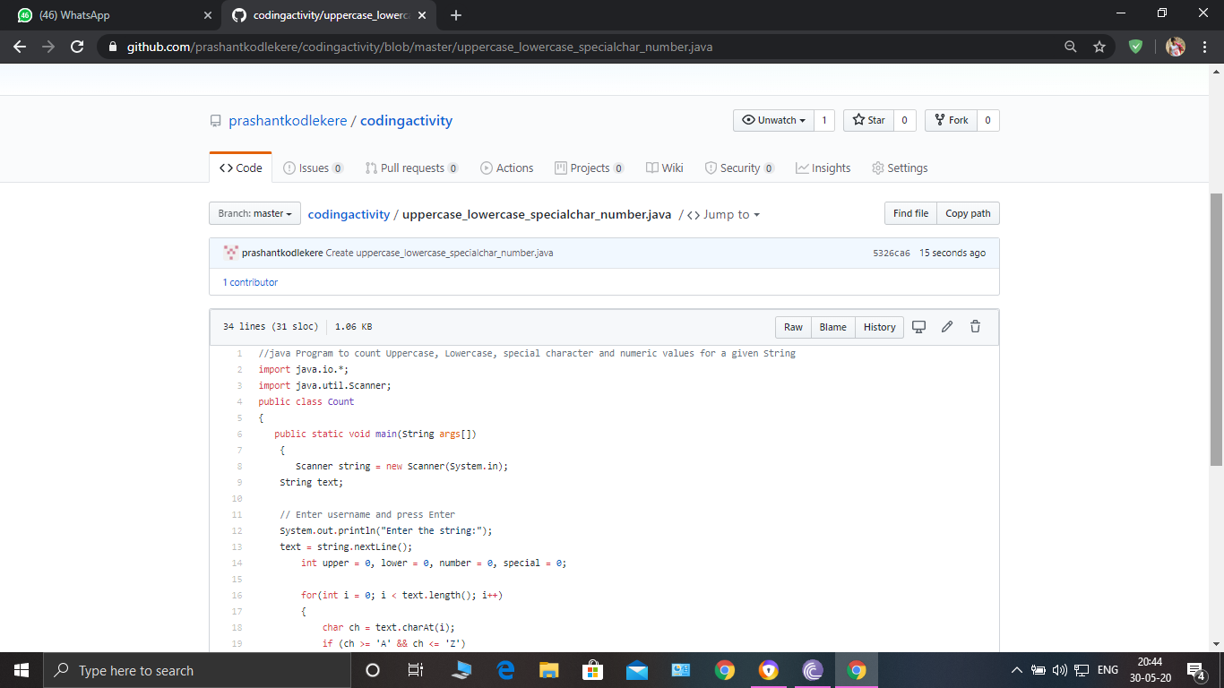

**The question I took to code is:**

Write a java Program to count Uppercase, Lowercase, special character and numeric values for a given String.

Code: The above snapshot is the code which I have uploaded in my Github repository.